Assignment 10.2

1.Write a hive query to find the top 20 destination people travel the most: Based on the given data

1.Select to locations and their count

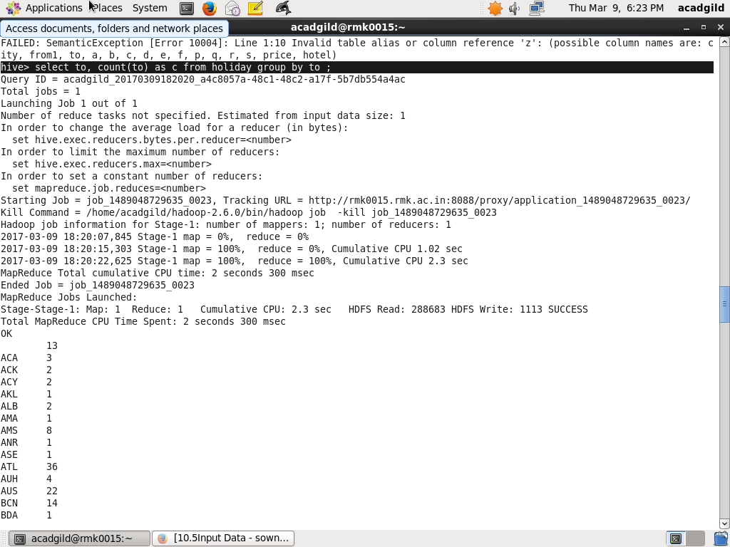

2.Sort them in descending order

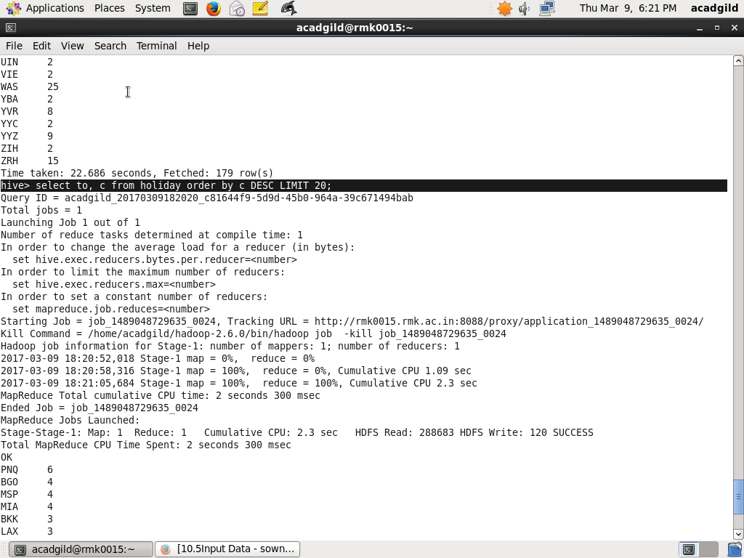

OUTPUT :TOP20 DESTINATION ALONG WITH THEIR COUNT

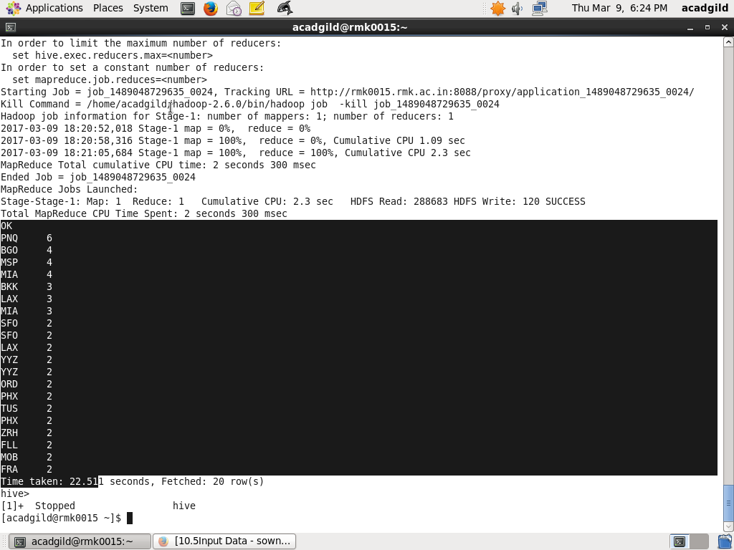

2. Write a hive query to find the top 20 locations from where people

travel the most

1.Select from locations and their count. dsdsacccc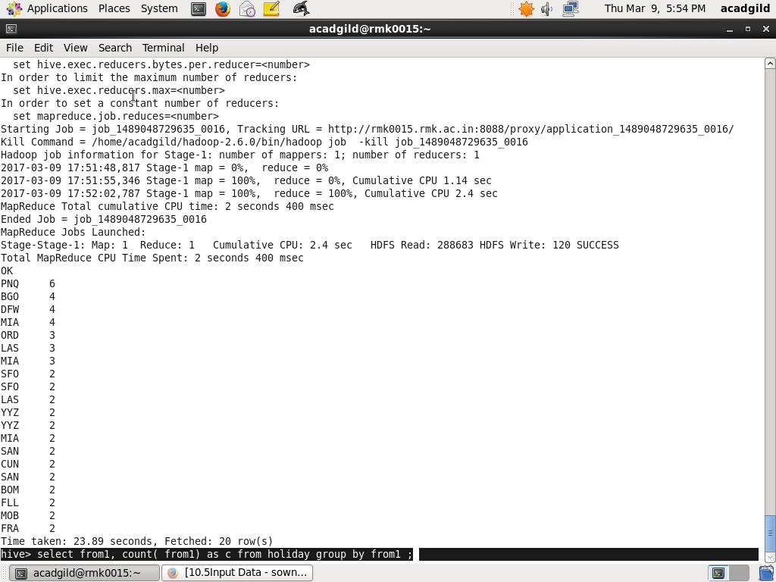

2.Sort them in descending order and find top 20

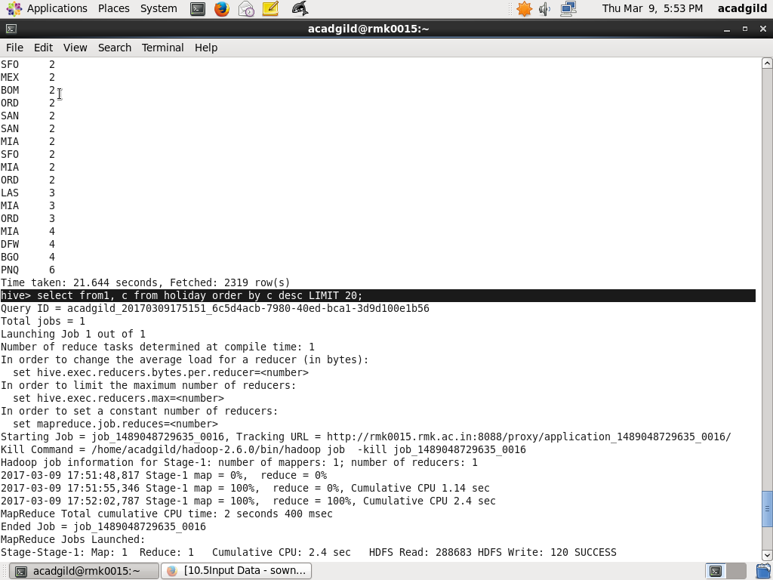OUTPUT :TOP 20 FROM LOCATIONS ALONG WITH COUNT

